PROJECT REPORT

VISUALIZATION TOOL FOR ELECTRIC VEHICLE CHARGE AND RANGE ANALYSIS

INTRODUCTION

* 1. Overview

A visualization tool for electric vehicle (EV) charge and range analysis is an essential software program that provides users with a graphical representation of the battery charge level and estimated range of their electric vehicles. The tool provides EV owners with critical information needed to plan their trips and avoid running out of battery charge while on the road.

The visualization tool collects data from the EV's battery management system and displays it in a user-friendly format, such as a graph or chart. It may also incorporate other data sources, such as weather and traffic conditions, to provide a more accurate prediction of the vehicle's range.

Some visualization tools may also include features such as trip planning and charging station locator to help users plan their journeys and locate charging stations along the way. Additionally, the tool may be able to provide users with suggestions on how to optimize their driving behavior to maximize range.

Overall, the visualization tool for electric vehicle charge and range analysis is an important tool for EV owners, as it provides them with critical information needed to plan their trips and make informed decisions about when and where to charge their vehicles.

* 1. Purpose

The purpose of a visualization tool for electric vehicle charge and range analysis is to provide users with a graphical representation of the charging and range data of their electric vehicles. This tool helps EV owners to make informed decisions about charging their vehicle and planning their trips.

With a visualization tool, users can see their vehicle's current state of charge, the amount of energy consumed, and the estimated range. They can also track their charging history, see how long it takes to charge their vehicle, and identify patterns in their charging behavior.

Furthermore, a visualization tool can help EV owners plan their trips by showing them the available charging stations along their route, their charging speed, and the estimated time needed to recharge their vehicle. This information is critical for EV owners to make informed decisions and avoid running out of power during their trips.

In summary, a visualization tool for electric vehicle charge and range analysis helps users monitor and manage their electric vehicle's charging and range performance, providing them with the data they need to make informed decisions and optimize their EV driving experience.

2 Problem definition and design thinking.

2.1 Empathy map

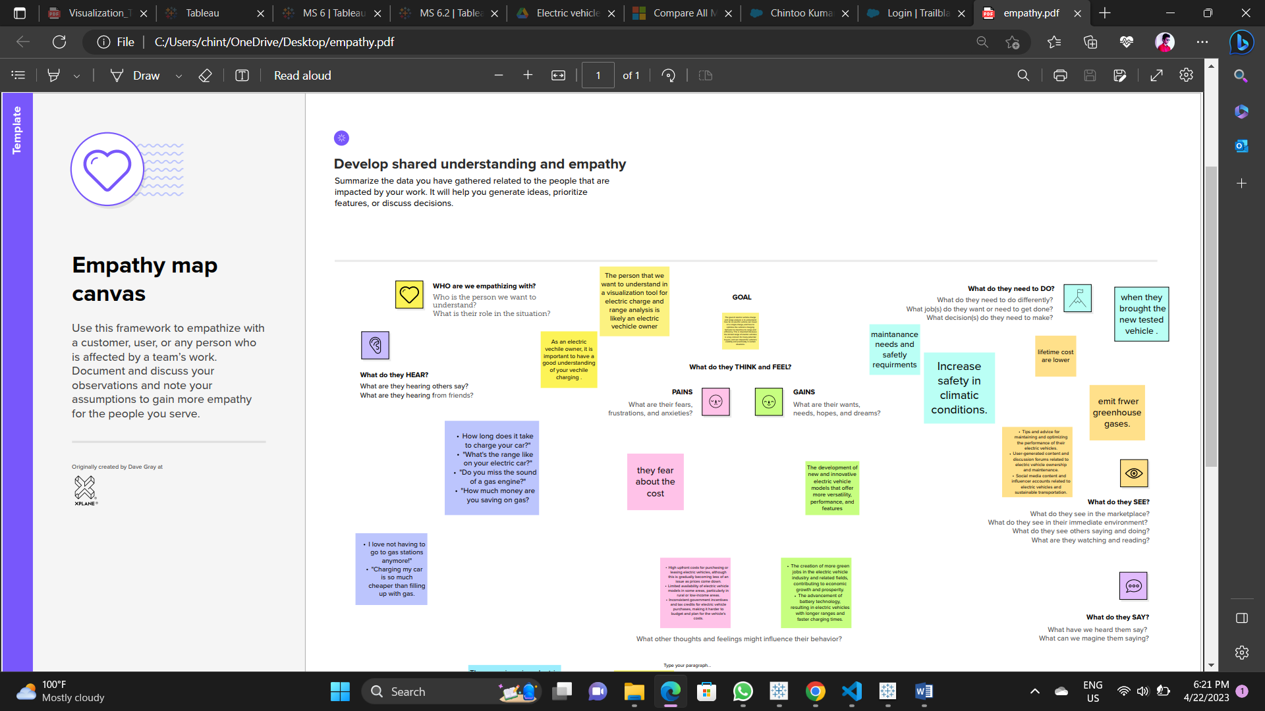

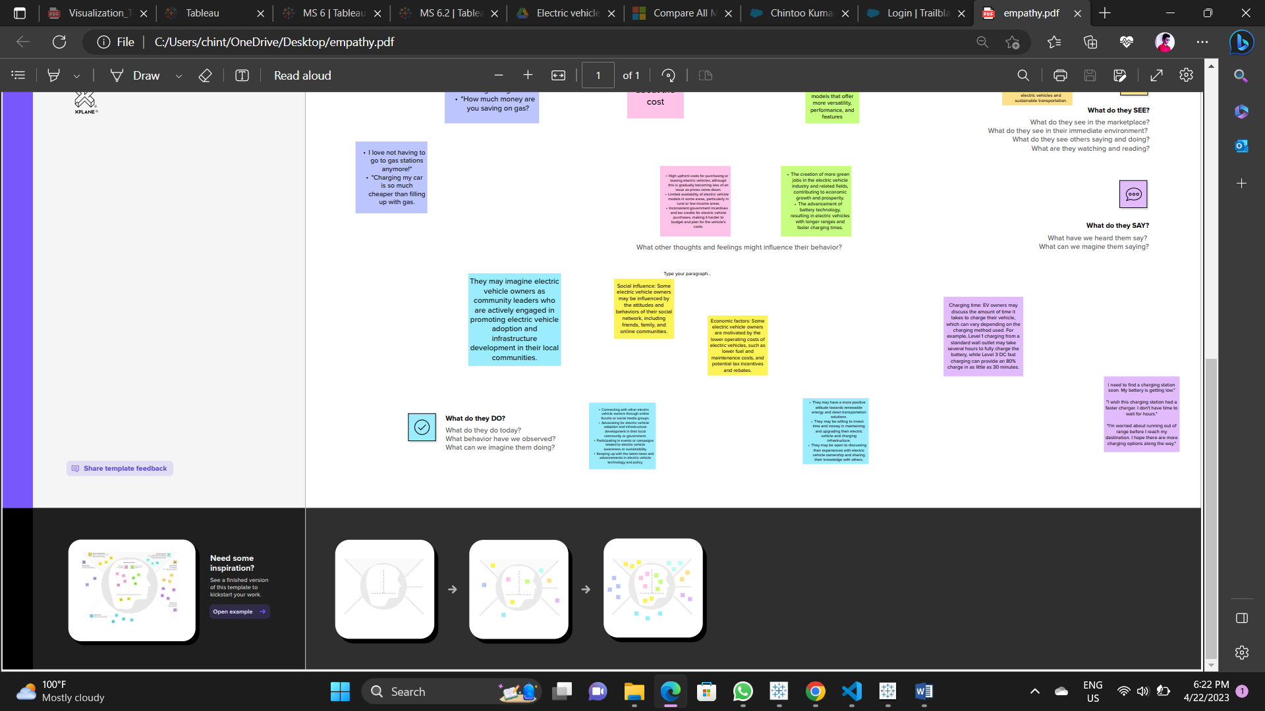

2.2 Ideation and Brainstorming Map

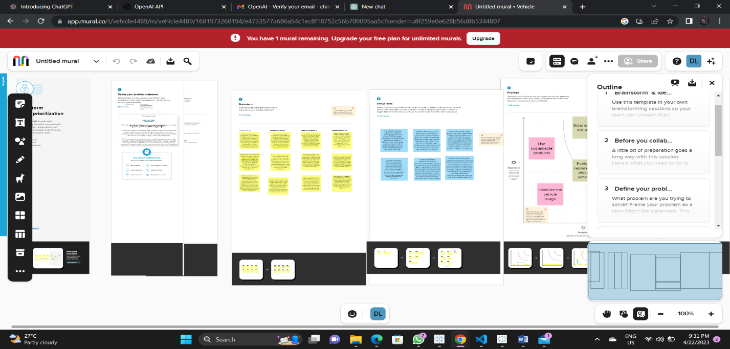

3 RESULT

Activity & Screenshot

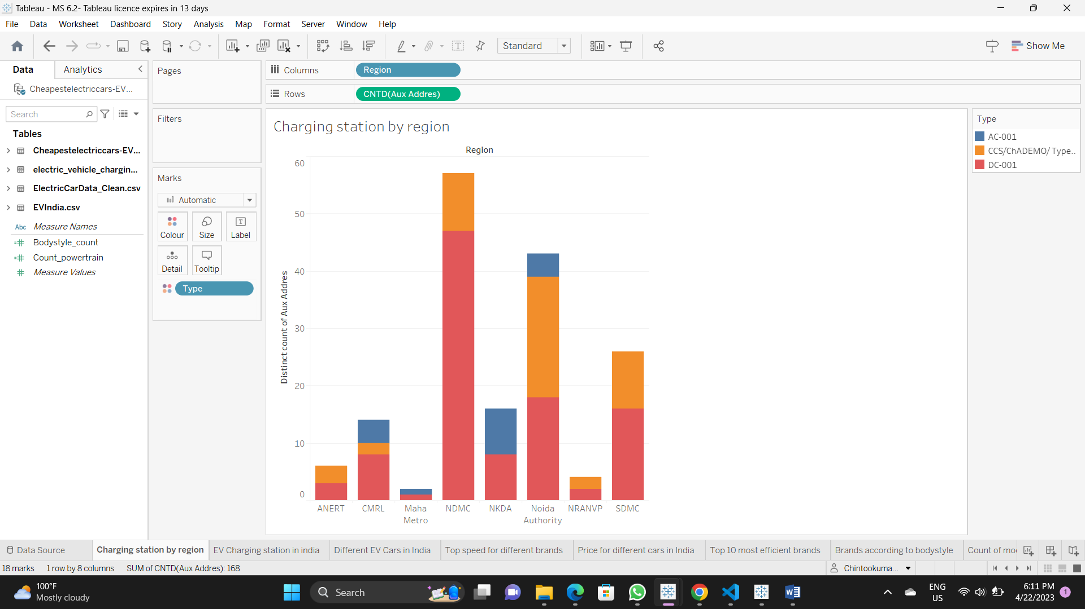

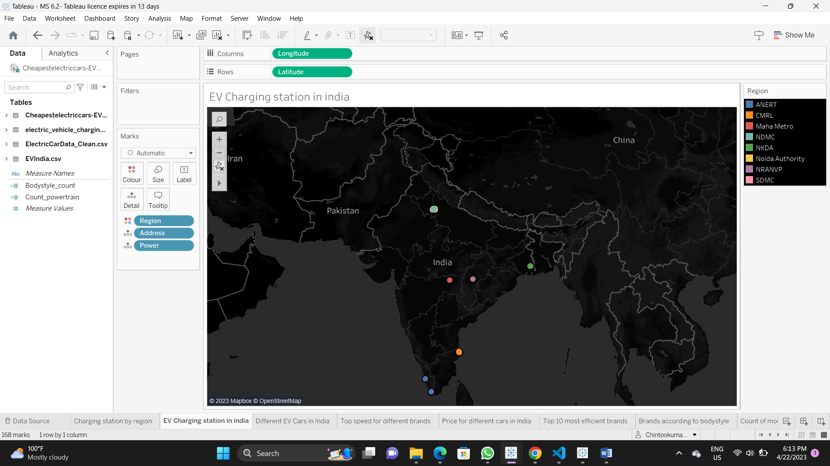

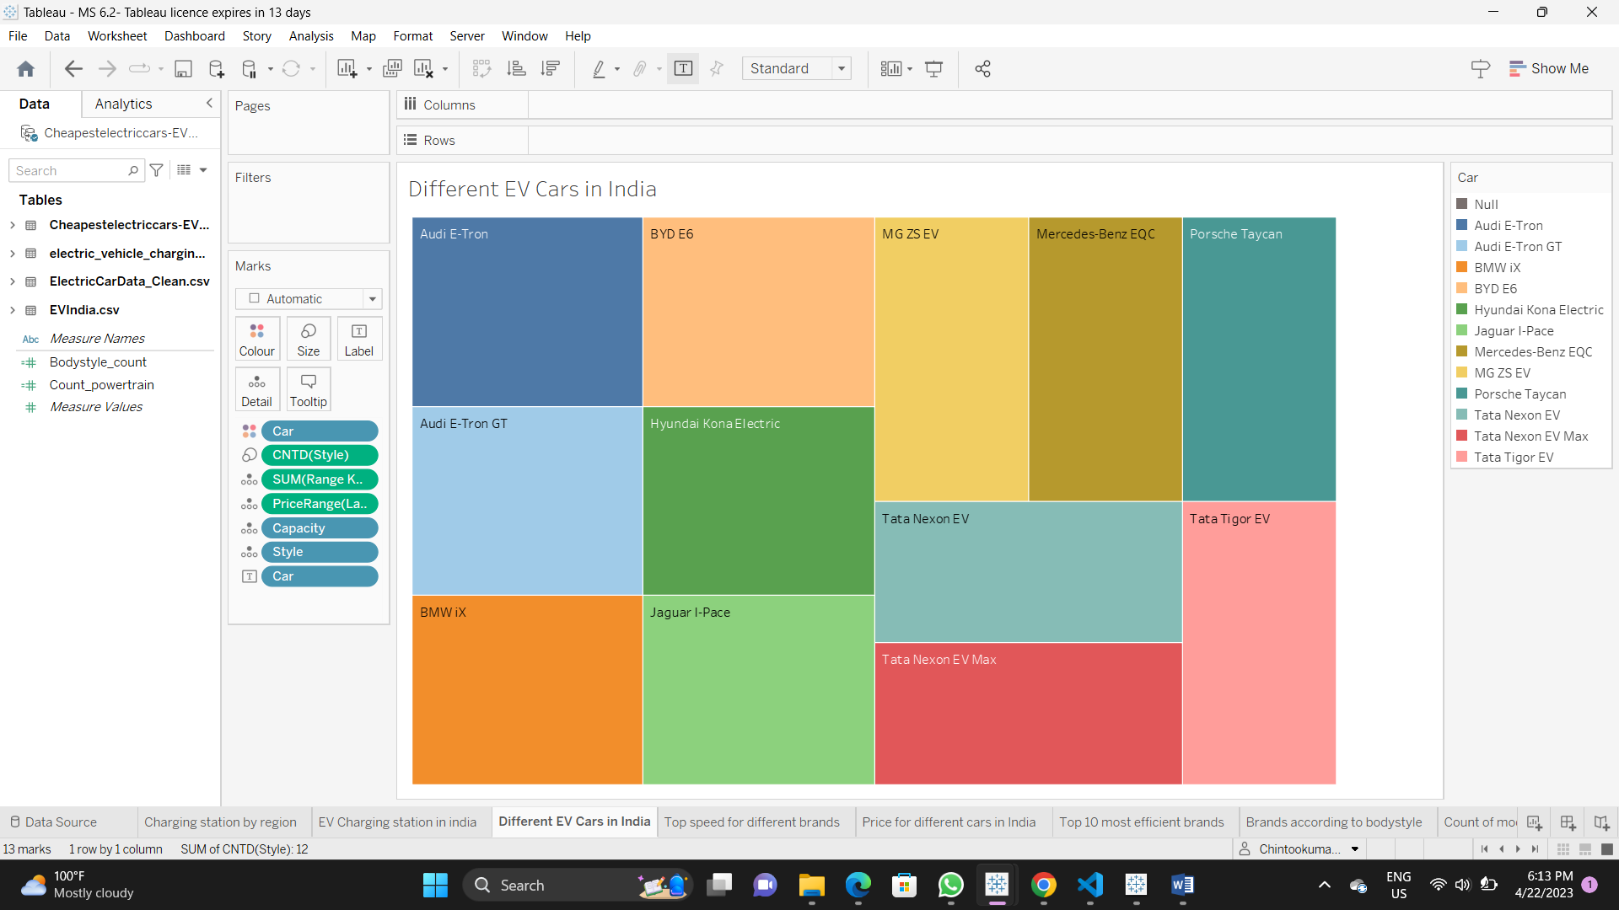

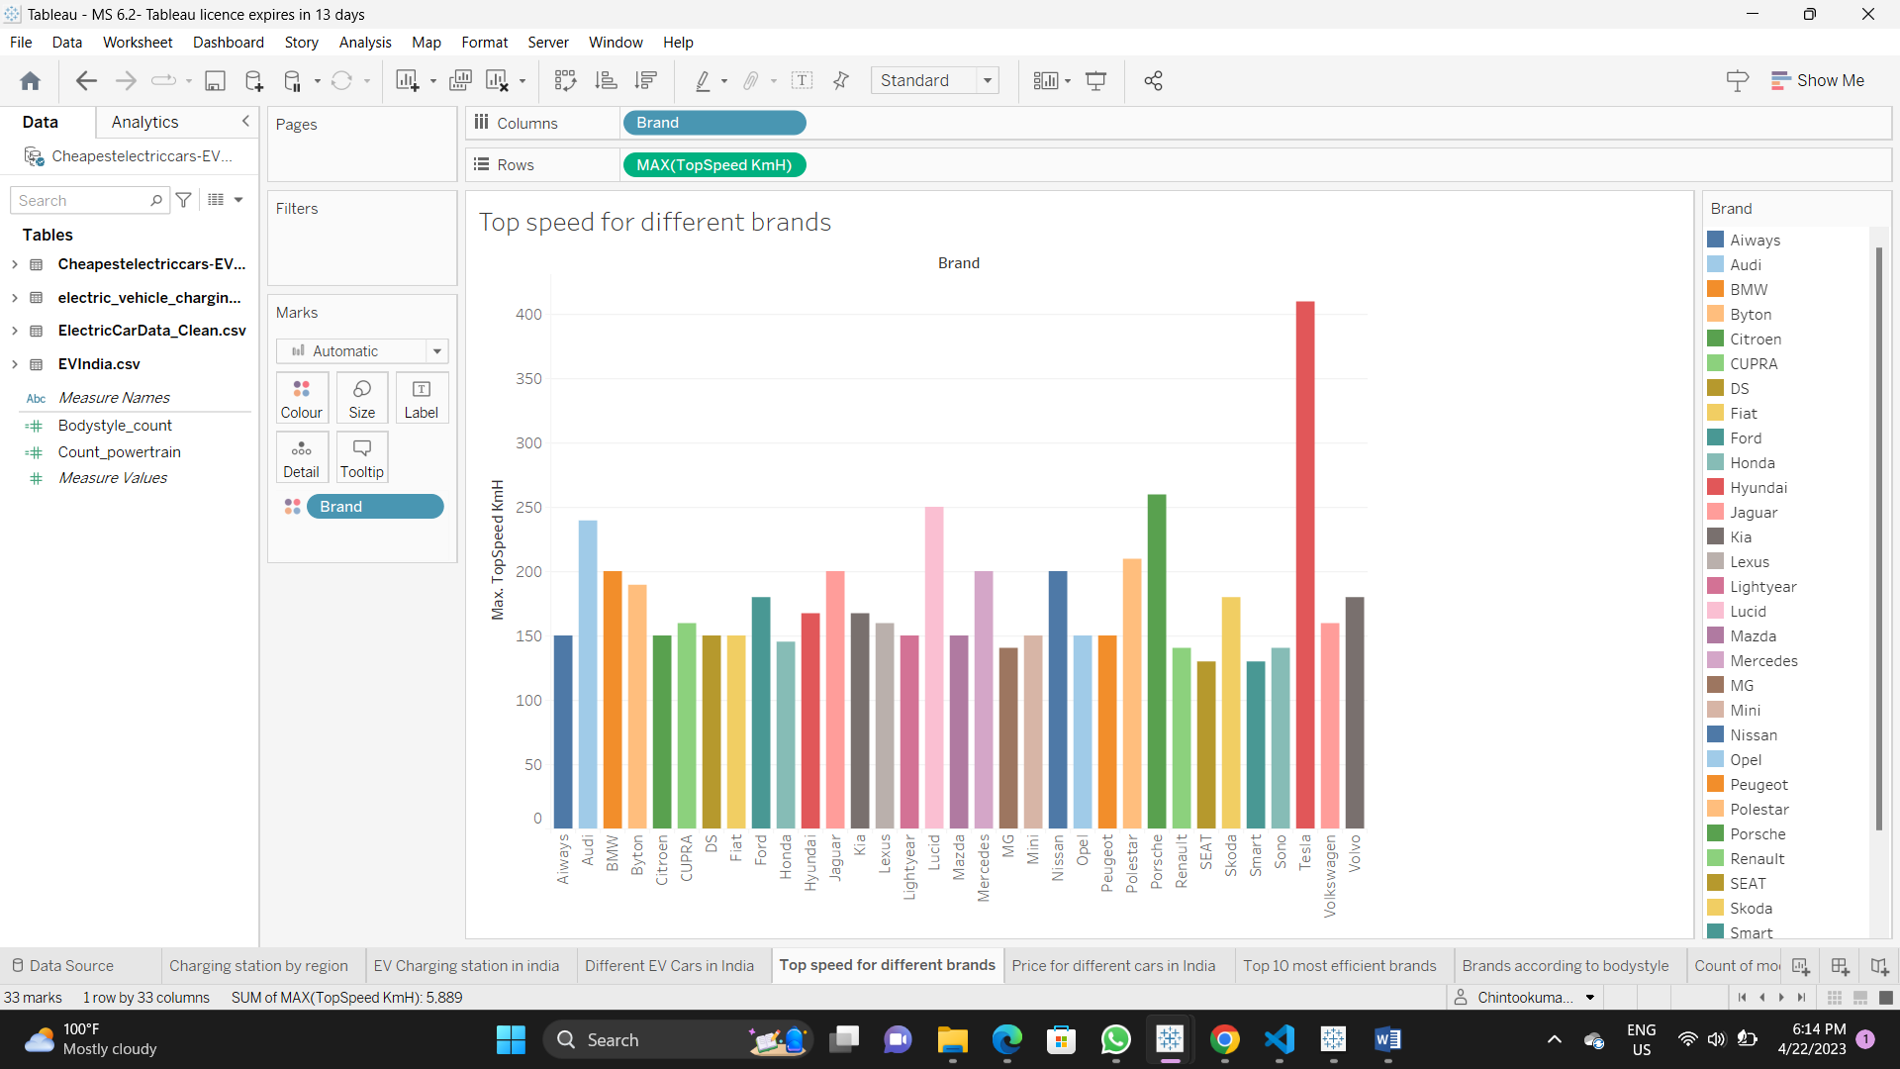

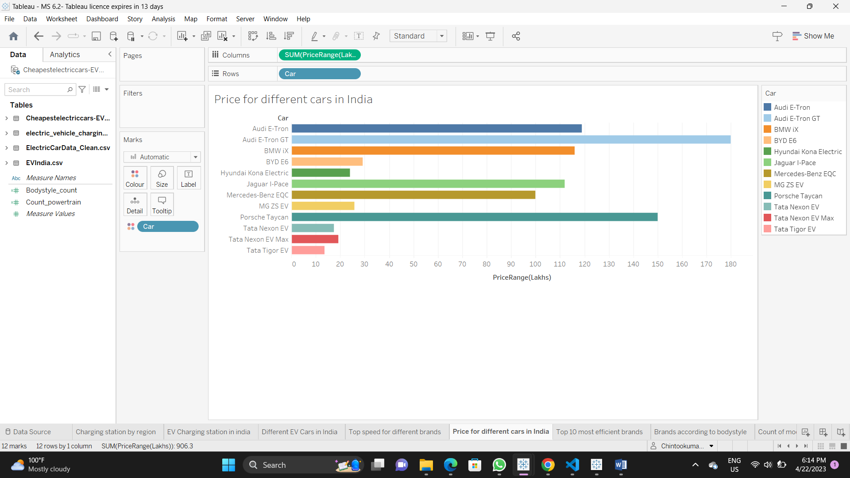

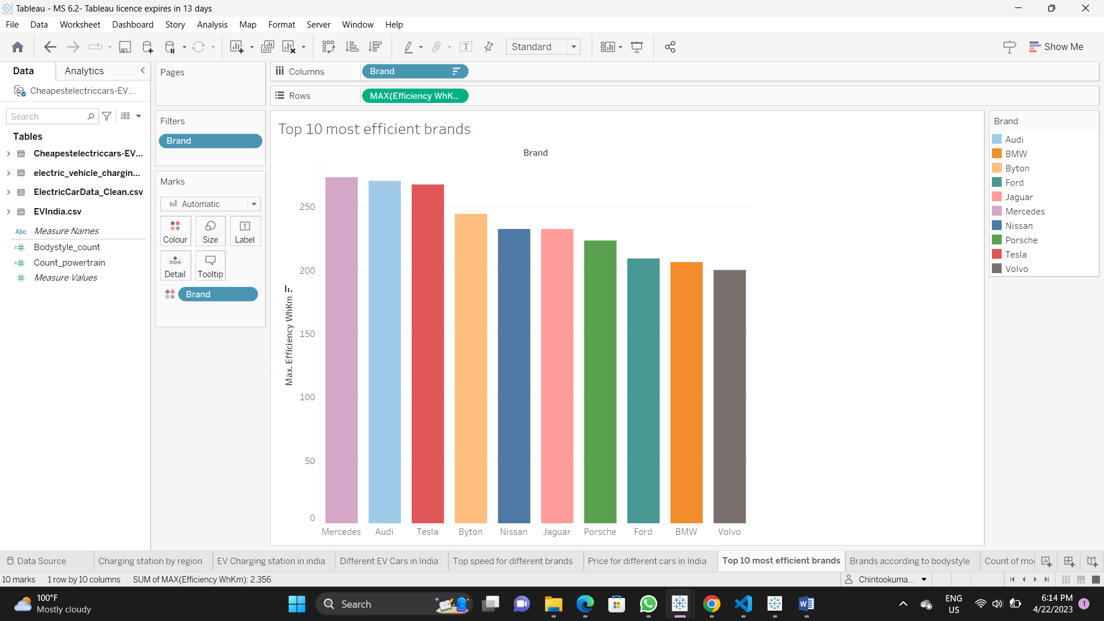

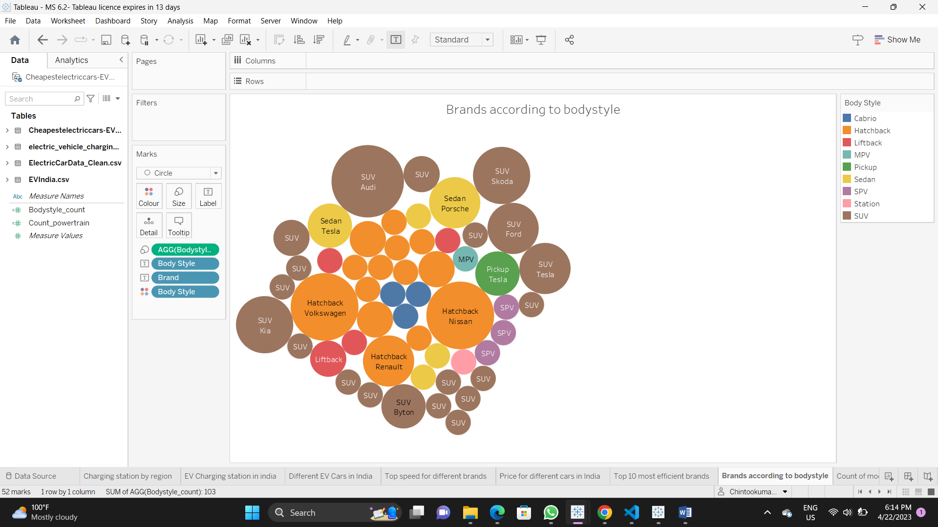

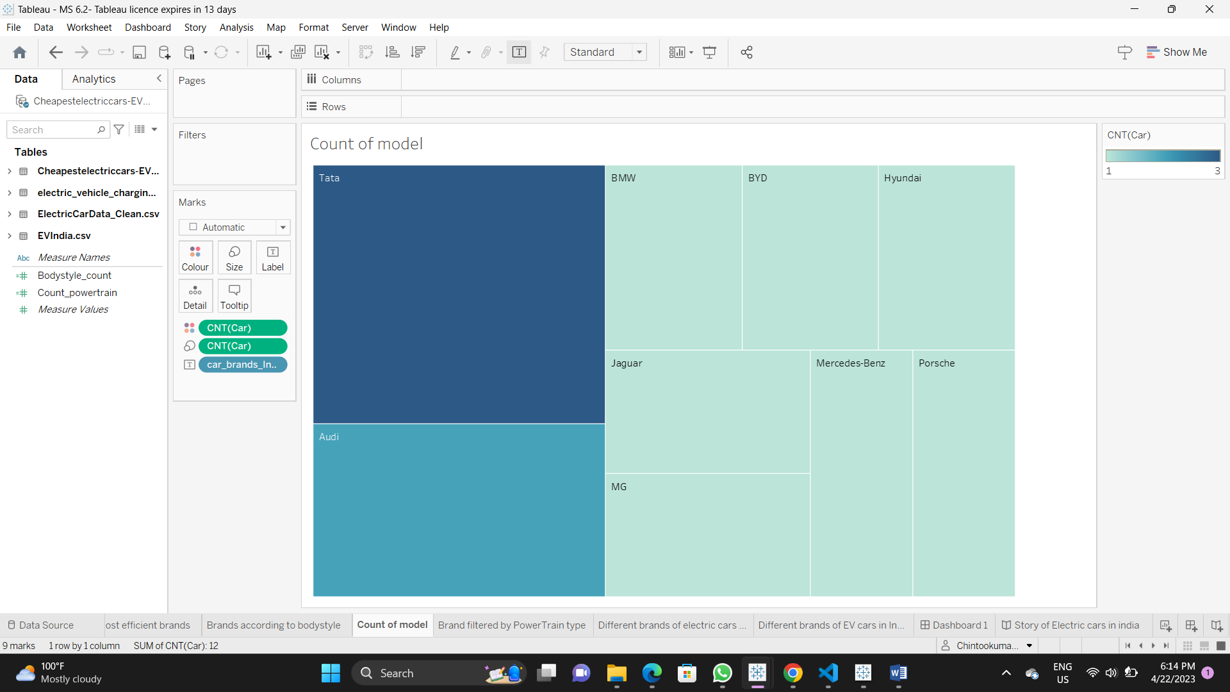

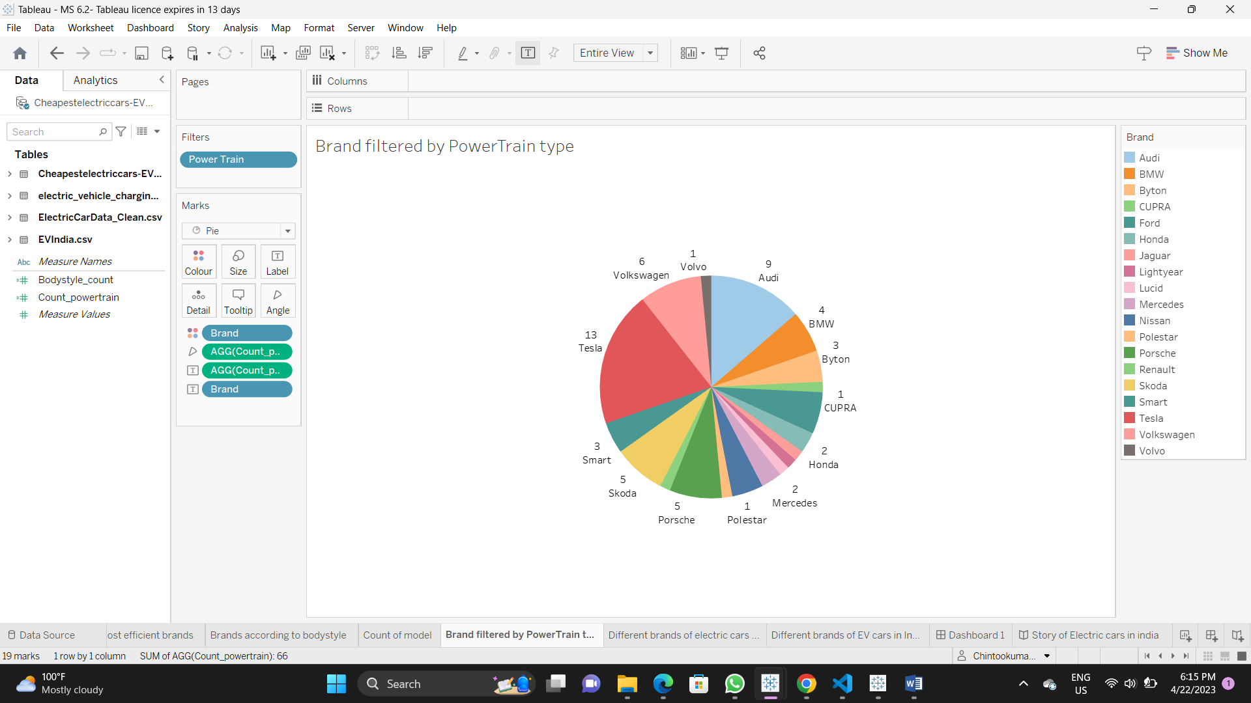





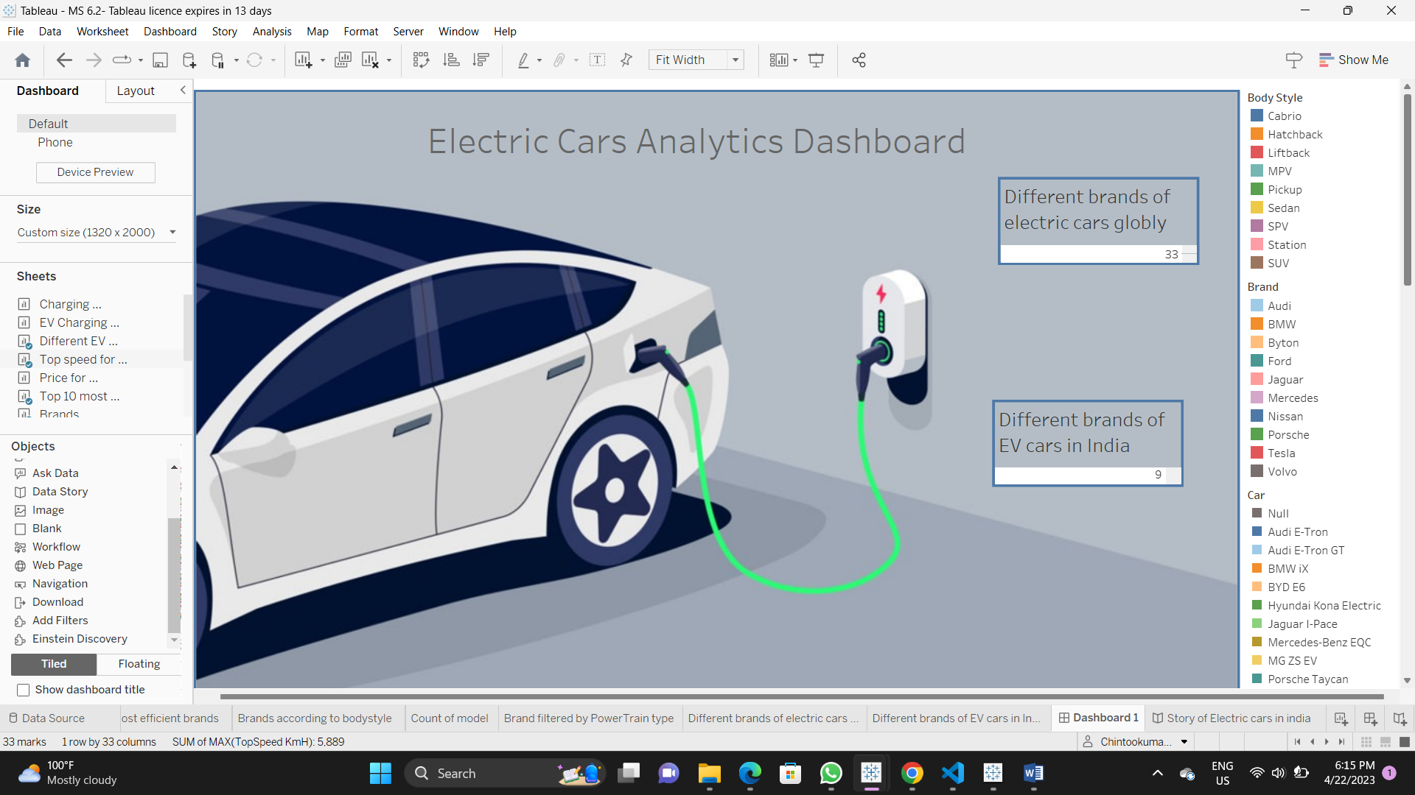

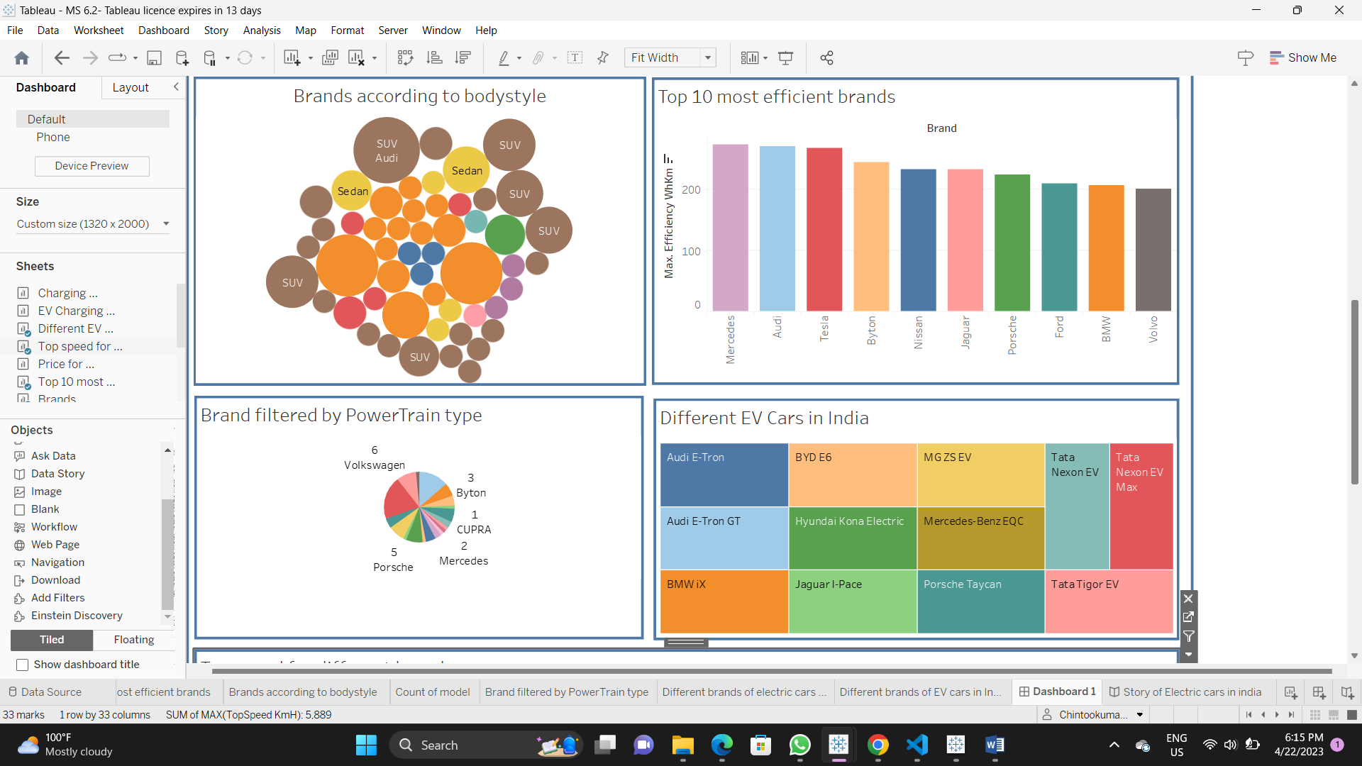

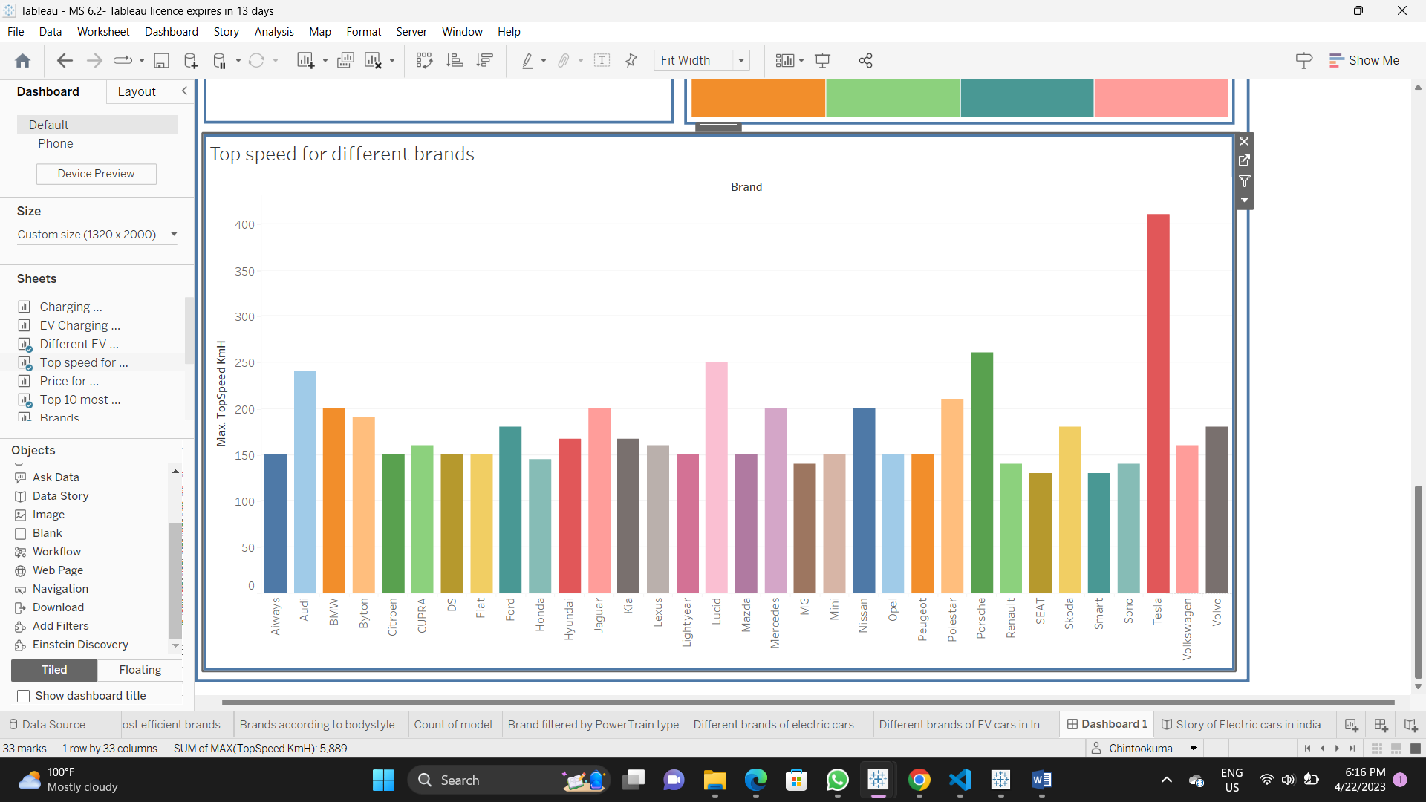

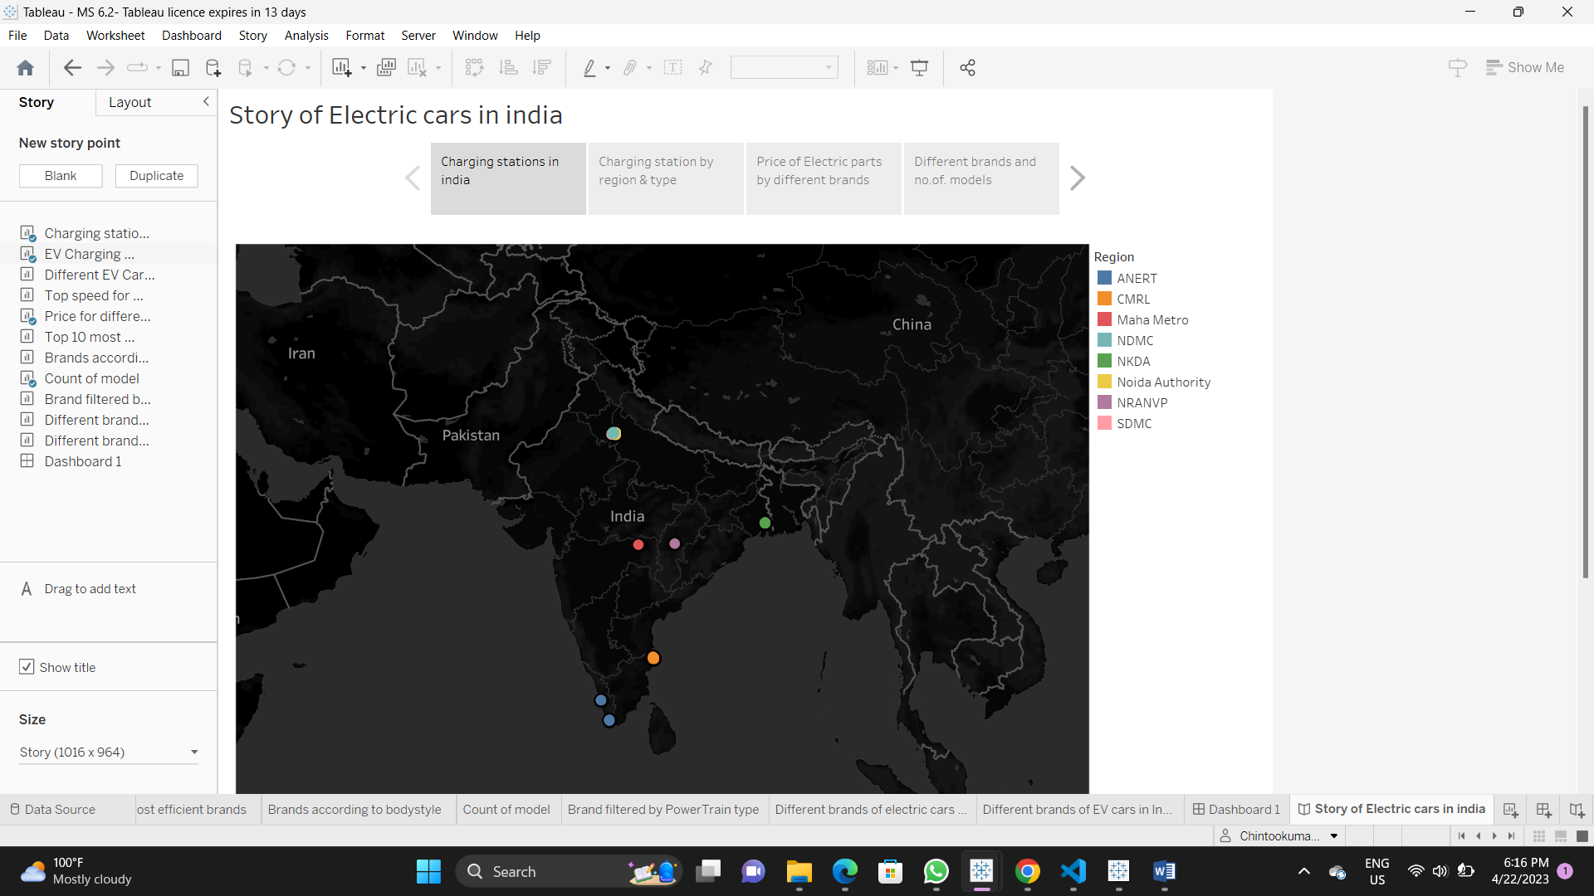

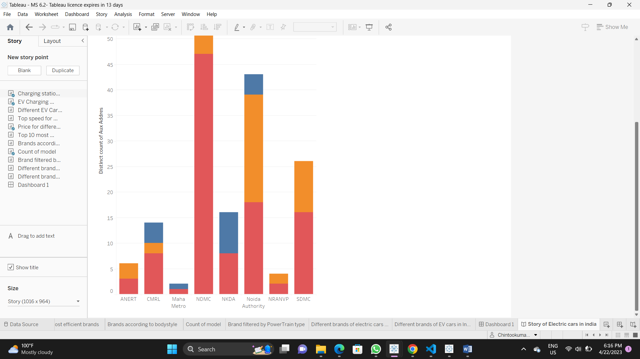

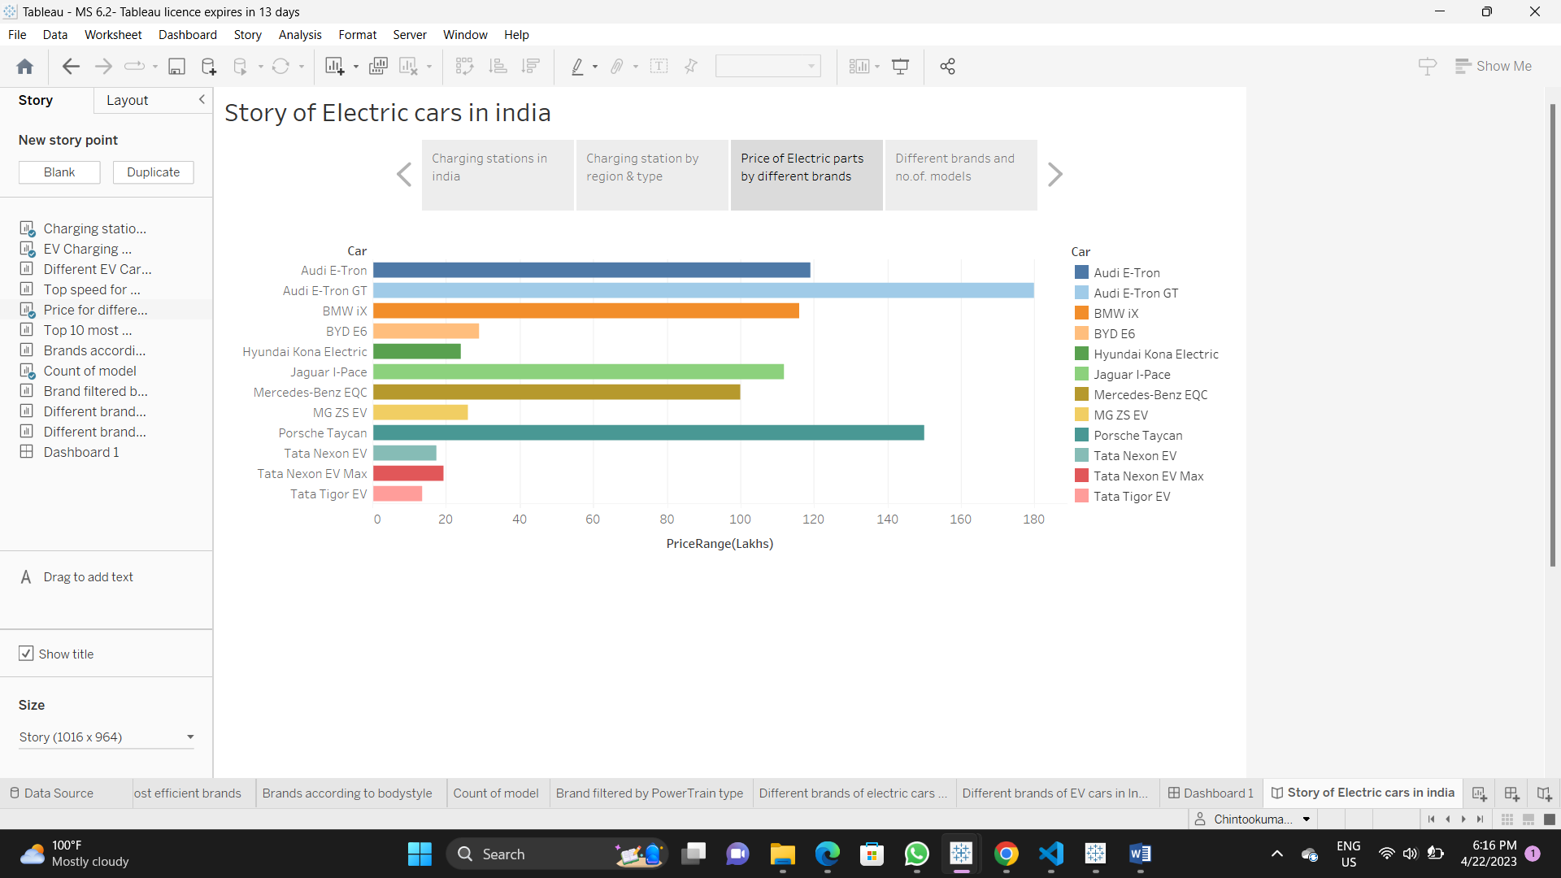

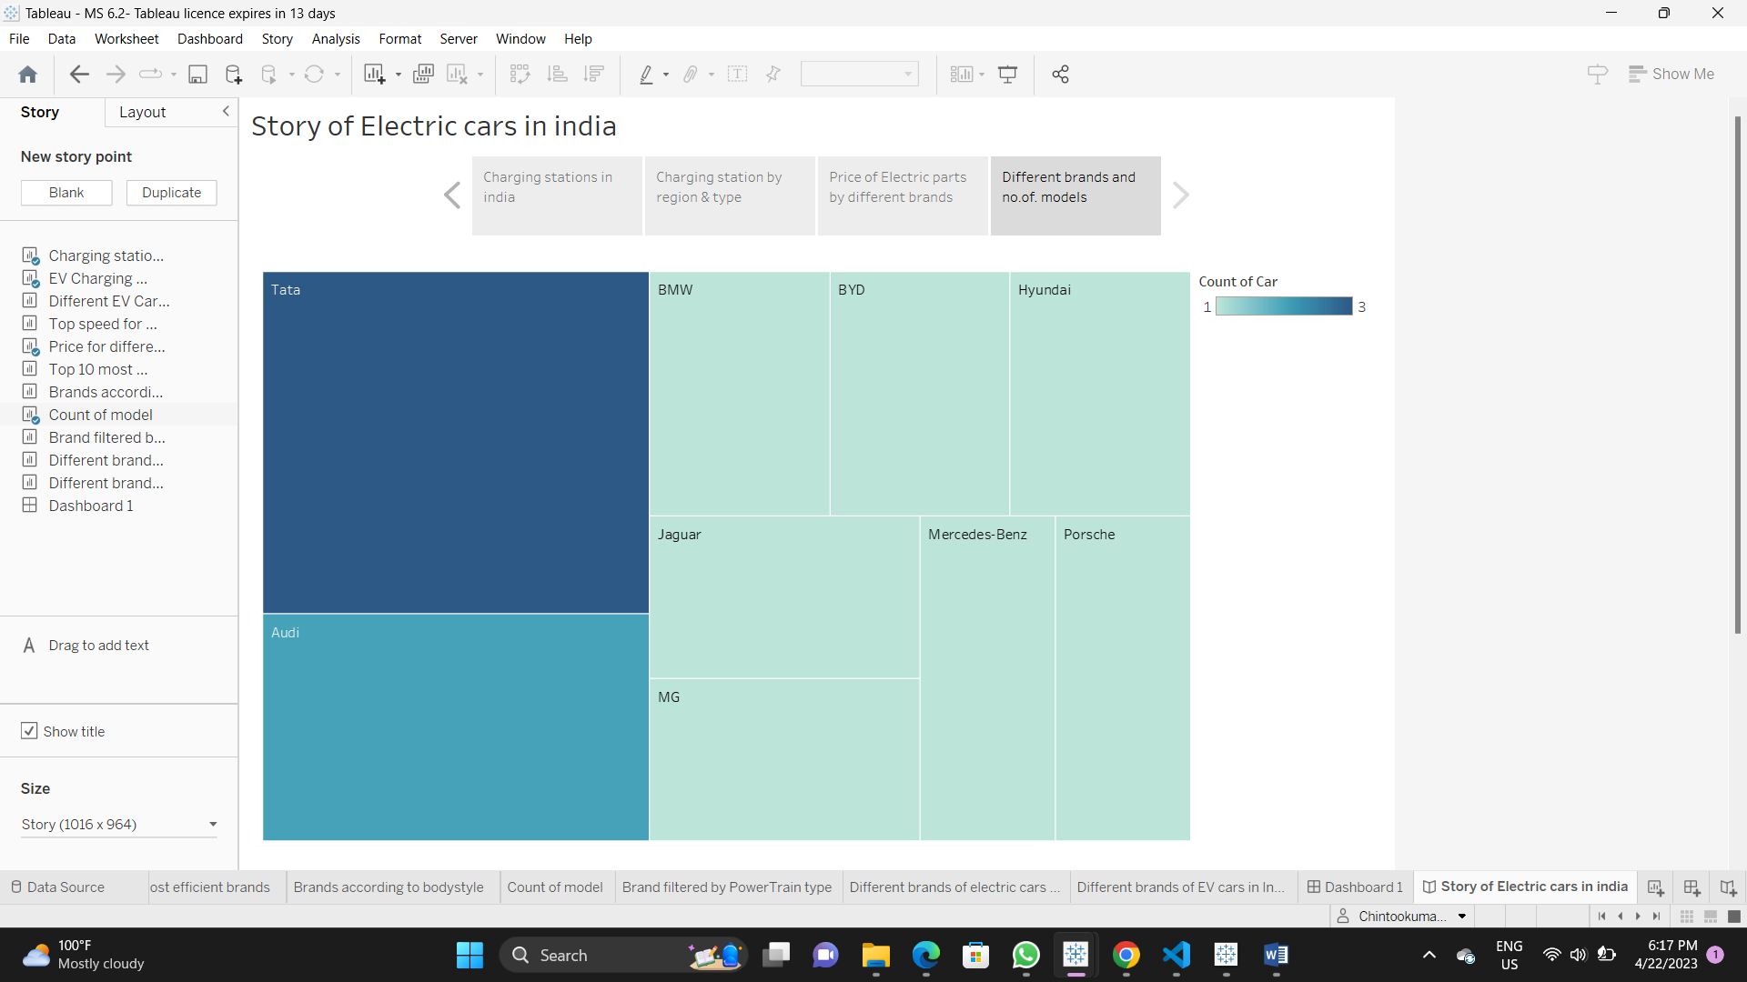

4 TRAILHEAD Profile Public URL

Team Leader - <https://trailblazer.me/id/dharshini17>

Team Member 1 – <https://trailblazer.me/id/dhanalakshmi1905>

Team Member 2 – <https://trailblazer.me/id/malarguzhali>

Team Member 3 – <https://trailblazer.me/id/chintoo2521>

5 ADVANTAGE & DISADVANTAGE

Several advantages, including :

Visualizations can be very useful for analyzing data related to electric vehicle (EV) charging and range. Here are some advantages of using visualization tools for EV charge and range analysis:

1. Clear and concise representation of data: Visualization tools can present complex data related to EV charging and range in a clear and concise manner. This can help users quickly understand patterns and trends in the data, and identify any issues or areas for improvement.

2. Real-time monitoring: Visualization tools can provide real-time monitoring of EV charging and range data. This can help EV owners or fleet managers keep track of the charging status of their vehicles, and make informed decisions about when and where to charge.

3. Customizable analysis: Visualization tools can be customized to display specific data sets, such as charging times or energy usage, depending on the needs of the user. This can help users analyze the data in a way that is most relevant to their specific situation.

4. Improved decision-making: By presenting data in a visual format, visualization tools can help users make more informed decisions about EV charging and range. For example, a fleet manager can use a visualization tool to identify which vehicles need to be charged first, based on their current range and the locations of available charging stations.

5. Increased efficiency: Visualization tools can help increase the efficiency of EV charging and range analysis. By providing a quick and easy way to analyze data, users can spend less time manually reviewing data sets and more time taking action to improve the performance of their EVs.

Overall, visualization tools can provide a number of benefits for EV charge and range analysis, helping users make more informed decisions, improve efficiency, and better understand their data.

Potential disadvantages, including:

While visualization tools for electric vehicle charge and range analysis can be very helpful in providing a clear understanding of the data, there are some potential disadvantages to keep in mind:

1. Complexity: Visualization tools can be quite complex and difficult to use, particularly for individuals who are not familiar with the specific tool or with data analysis in general. This can lead to frustration and make it more difficult for users to fully utilize the tool.

2. Data accuracy: The accuracy of the data used in the visualization tool can have a significant impact on the usefulness of the tool. If the data is inaccurate or incomplete, the tool may provide misleading information, which can be particularly problematic when making decisions about electric vehicle charging and range.

3. Cost: Some visualization tools can be quite expensive, particularly if they require specialized hardware or software. This can make it difficult for individuals or organizations with limited budgets to access these tools.

4. Dependence on data: Visualization tools are only as good as the data that they are based on. If the data is not available or is not up to date, the tool may not provide useful information.

5. Limited scope: Visualization tools are typically designed to analyze a specific type of data or a specific aspect of electric vehicle charging and range. This can limit their usefulness in other areas and may require the use of multiple tools to get a complete picture of the data.

6 APPLICATION

Some of the most effective and widely used methods include:

Visualization tools can be extremely helpful in analyzing electric vehicle charge and range data, as they allow users to easily interpret and understand complex information. Here are some possible applications of visualization tools for electric vehicle charge and range analysis:

1. Charge and Range Mapping: A visualization tool can create maps showing the locations of charging stations and the range of electric vehicles. This can help drivers plan their routes and estimate how far they can travel on a single charge.

2. Battery Charge and Discharge Analysis: A visualization tool can plot the battery charge and discharge rates of an electric vehicle over time. This can help drivers understand how their driving habits affect the battery life and how to optimize their charging strategy.

3. Charging Station Utilization Analysis: A visualization tool can display the utilization of charging stations over time, allowing planners to determine where additional charging infrastructure may be needed.

4. Energy Consumption Analysis: A visualization tool can help users understand the energy consumption of an electric vehicle and identify opportunities for efficiency improvements.

5. Charging Network Analysis: A visualization tool can display the charging network of an area, showing where charging stations are located and their availability. This can help electric vehicle owners plan their trips and reduce range anxiety.

Overall, visualization tools can help electric vehicle owners and planners optimize the use of charging infrastructure and improve the overall efficiency of electric vehicles.Top of Form

Bottom of Form

1. Conclusion

As a language model, I do not have access to specific information about a visualization tool for electric vehicle charge and range analysis. However, in general, a good conclusion for a data visualization tool should summarize the key findings and insights that the tool provides.

It is important to highlight the benefits and limitations of the tool and any recommendations for future improvements or iterations. Additionally, the conclusion should address how the tool can be useful for different stakeholders such as policymakers, EV owners, and energy providers.

Overall, the conclusion should provide a clear and concise summary of the tool's capabilities, its usefulness in solving specific problems, and its potential impact on the broader EV ecosystem.

8 Future Scope

The future scope of a visualization tool for electric vehicle charge and range analysis is significant, as the use of electric vehicles (EVs) continues to increase around the world. Here are some potential areas of development:

1. Integration with Smart Grids: With the integration of smart grids, EVs can be charged during off-peak hours when electricity demand is low. The visualization tool can show the user the best time to charge their vehicle, based on the current energy prices and the user's schedule.

2. Route Planning: The tool can provide route planning options for EV drivers that show the range of the vehicle and the location of charging stations along the way. This can help drivers plan their trips and ensure they have enough charge to reach their destination.

3. Battery Optimization: The tool can provide information on how to optimize battery life and prolong the lifespan of the battery. This can include advice on how to charge the battery and when to avoid fast charging.

4. Real-Time Analytics: The tool can provide real-time analytics on the vehicle's energy consumption, charging status, and range. This information can help the driver make informed decisions about when and where to charge their vehicle.

5. Vehicle-to-Grid Integration: The tool can integrate with vehicle-to-grid (V2G) technology, which allows EVs to discharge their stored energy back into the grid during times of peak demand. The visualization tool can show the user how much energy their vehicle is contributing to the grid and how much money they are saving by doing so.

Overall, a visualization tool for electric vehicle charge and range analysis has significant potential to help EV drivers optimize their driving experience and reduce their energy consumption. As the use of EVs continues to grow, the demand for such tools will likely increase, making this an exciting area of development for the future.